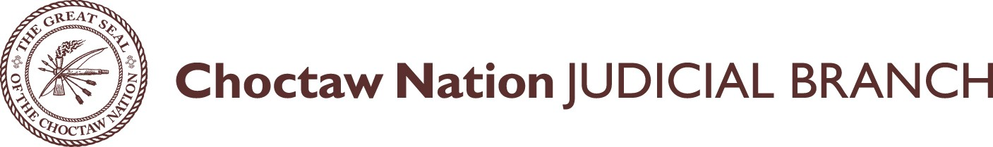

IN THE DISTRICT COURT FOR THE CHOCTAW NATION OF OKLAHOMA

Thank you for your interest in the Choctaw Nation Bar Association!

We welcome any person who:
- Possesses good moral character, due respect for the law and fitness to practice law;
- Is at least 18 years of age; and
- Is an attorney at law and is admitted to practice before the highest court of any state of the United States and is a member in good standing of such Bar or has been licensed by the Oklahoma Supreme Court as a Licensed Legal Intern; however, all interns must comply with the provisions of Oklahoma law while practicing in the courts of the Choctaw Nation.
Please complete the Application for Admission and submit same to the following email or Address:
Sandy Stroud
Choctaw Nation Court Administrator
P.O. Box 1160 Durant, OK 74702
sstroud@choctawnation.comI

Your application will be reviewed, and if accepted, you will receive an invoice for the annual membership fee of $50.00. You can then mail your membership fee to the address above, or simply call our office at 580-920-7027 to pay by phone. Checks should be made payable to Choctaw Nation Court Clerk.
Attorneys who become members will be subject to a renewal fee of $50.00 on January 1st annually.

If you have any questions, please contact Sandy Stroud, Court Administrator at 580-924-8280, Extension 4195.

APPLICATION FOR ADMISSION TO CHOCTAW NATION OF OKLAHOMA BAR ASSOCIATION

I hereby make application for admission to practice as an attorney in the District Court and Appellate Court of The Choctaw Nation of Oklahoma. I further certify that the information contained in the application is correct to the best of my knowledge.

Full Name Signature of Applicant

Name of Firm:

Address: Phone:

Fax:

Email:

Bar Number: State:

Are you a CDIB card holder? Yes No
If yes, what Tribe:

Bar Associations in which you are currently a member in GOOD STANDING:

Bar Association Year of Admittance Bar Number

Schools and Universities:

Dated this day of , 20 .

Signature of Applicant

OATH FOR ADMISSION

I solemnly swear that I will support, protect and defend the Constitution of the United States, and the Constitution of the Choctaw Nation of Oklahoma; that I will do no falsehood, or consent that any be done in court, and if I know of any, I will give knowledge thereof to the judges of the court, that it may be reformed; I will not wittingly or knowingly promote, sue or procure to be sued, any false or unlawful suit, or give aid or consent to the same; I will delay no person for lucre or malice, but will act in the office of attorney in all courts according to my best learning and discretion with all good fidelity as well to the court as to my client, so help me God.

Signature of Applicant

